***Important note:*** Before installing or upgrading your Citrix Workspace please see Attachment B to make sure your computer meets the minimum requirements needed.

1. **DOWNLOAD** the latest Citrix Workspace App from: https://www.citrix.com/downloads/workspace-app/mac/workspace-app-for-mac-latest.html

Note: If you receive an error message regarding a Certificate, please see Attachment A.

1. **UNINSTALL** the old Citrix Workspace:
   1. Open the downloaded Citrix Workspace App file 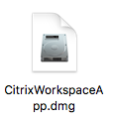
   2. Select Uninstall Citrix Workspace. If prompted, select Open.

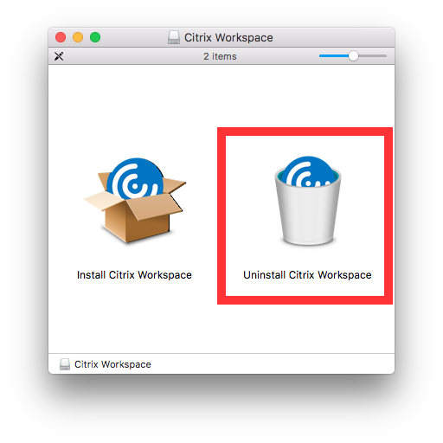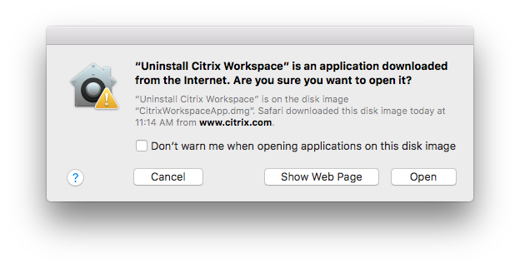

* 1. Follow the Wizard to uninstall the Citrix Workspace. Once successful, select Quit.

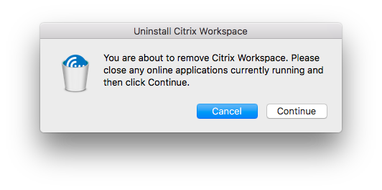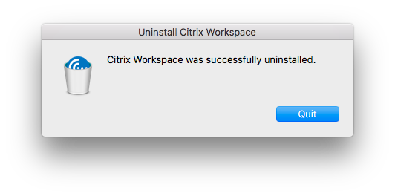

1. **REBOOT the Mac computer**. ***DO NOT skip this step***
2. **INSTALL** the Citrix Workspace:
   1. Open the downloaded Citrix Workspace file. Select Install Citrix Workspace, and follow the wizard to install Citrix Workspace.

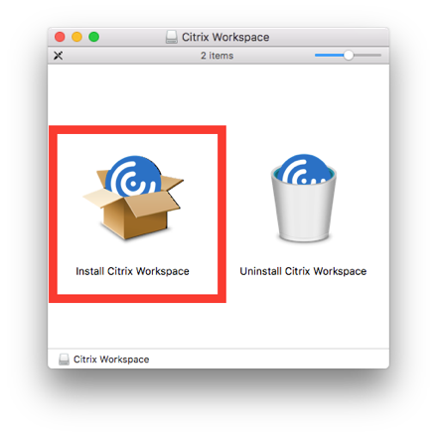

* 1. When prompted, DO NOT add an account. Leave the checkbox for Add Account

*unchecked*.

* 1. Complete the installation.
  2. If prompted via an automatic update, DO NOT update to the new Citrix Workspace Client (v18)

1. **CONFIGURE** the Citrix Workspace:
   1. Launch the Citrix Workspace App 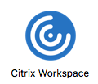 from your Applications folder.
   2. Login with your CHOA Network credentials

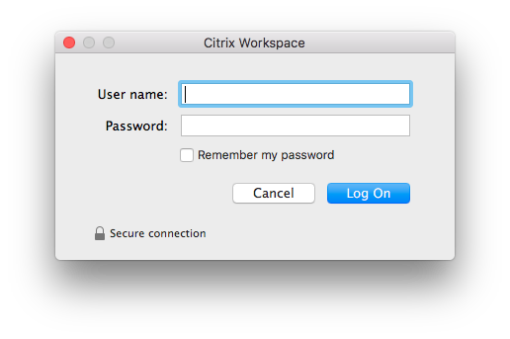

* 1. In the Add Account dialog box, add [https://anywhere.choa.org](https://anywhere.choa.org/) and select Add. A drop down list will appear. Select CTX-ATLDC-STORE.

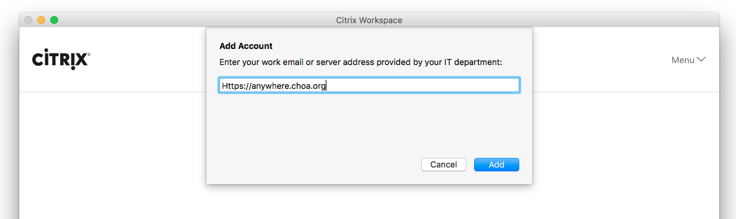

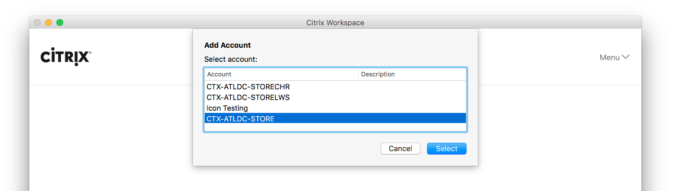

* 1. Once logged in, you should be in the Citrix Anywhere Portal

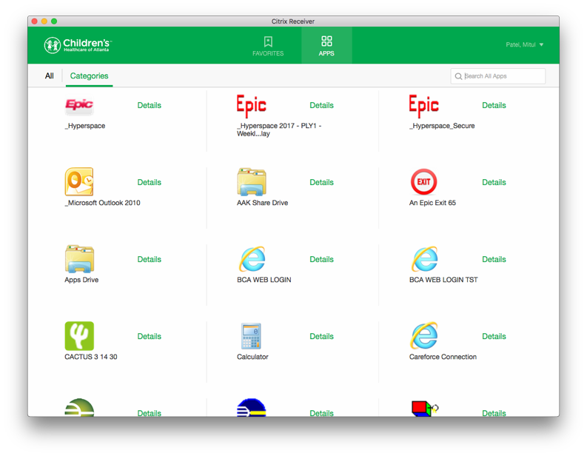

***Important note:*** If you are having trouble with performance, such as extremely long application load times, log off and log back in. If that does not resolve your issue, please contact the Solution Center at 404-785-6767.

# ATTACHMENT A:

**Download the two Citrix Certificates**

Download the Trusted Secure Certificate from: <https://cws.choa.org/mac/certificate/Trusted%20Secure%20Certificate%20Authority%205.cer>.

(Save the file to your computer)

Download the RSA Certificate from https://cws.choa.org/mac/certificate/RSA.cer

(Save the file to your computer)

# Installing the certificates

Open the downloaded files one by one and click “Install Certificate” (Trusted Secure Certificate Authority 5.cer and RSA.cer)

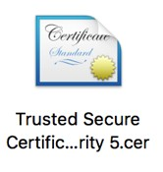

A Keychain Access window should open up with a smaller window within it asking if you want to Add Certificate. Make sure Keychain: **System** is selected. Select **Add**.

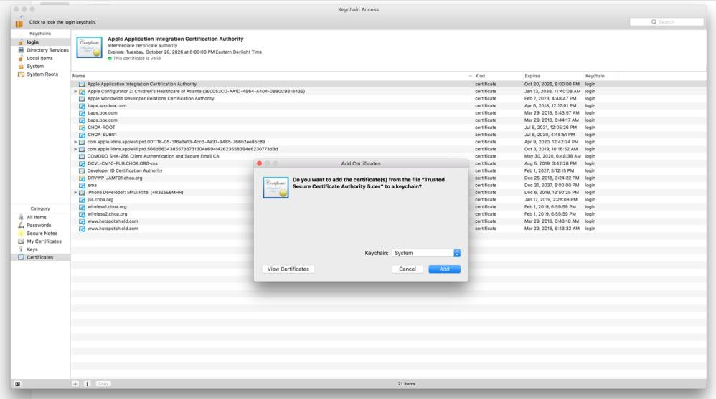

You will be prompted for your computer username and password (this maybe different from your AD/Network credentials). Enter password and select **Modify Keychain**.

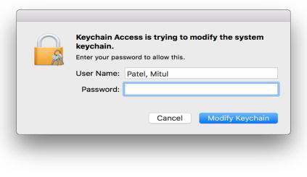

Close all windows and reboot Machine

# ATTACHMENT B:

# Minimum Requirements:

# Mac OS 10.11.x

# Mac OS 10.12.x

# Mac OS 10.13.x

# Mac OS 10.14.x

# How to check:

# Click the Apple Icon on the top left and About This Mac

# 

1. Confirm your machine is running the appropriate OS Version

