**Download the Citrix Certificate.**

Download the Citrix receiver from your email to your computer.

**Installing the certificate**

Double click on the certificate (Trusted Secure Certificate Authority 5.cer)

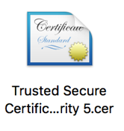

A Keychain Access window should open up with a smaller window within it asking if you want to Add Certificate. Make sure Keychain: **System** is selected. Select **Add**.

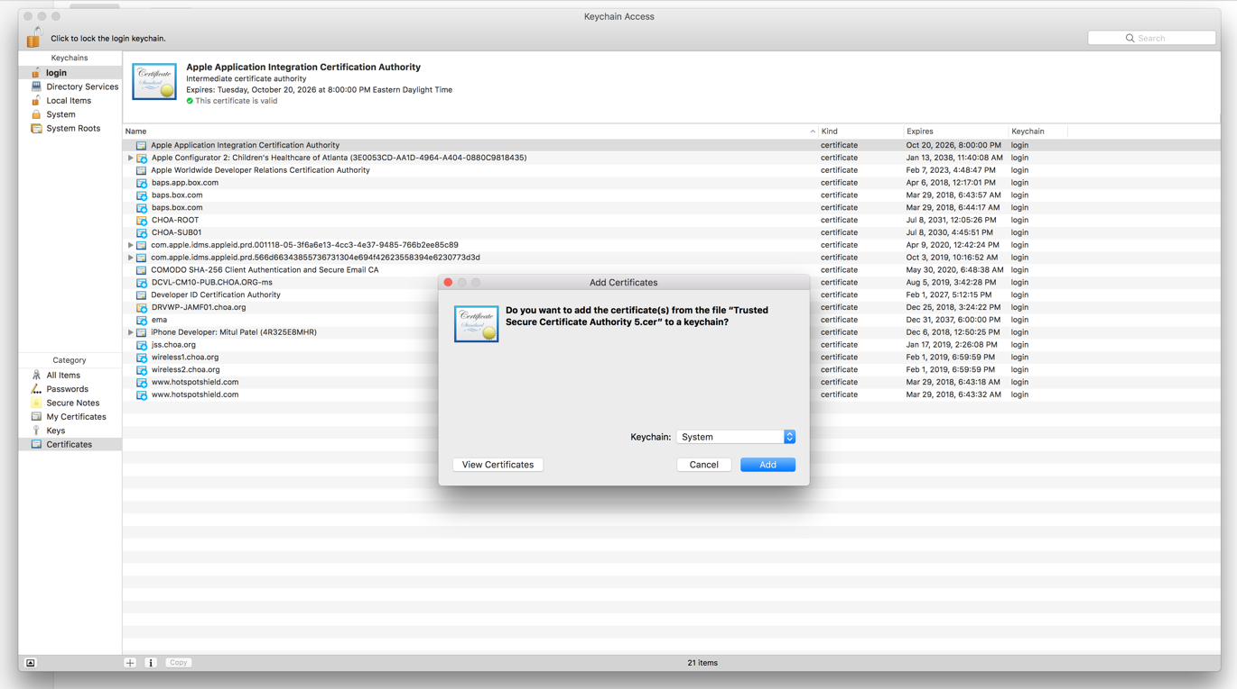

You will be prompted for your computer username and password (this maybe different from your AD/Network credentials). Enter password and select **Modify Keychain**.

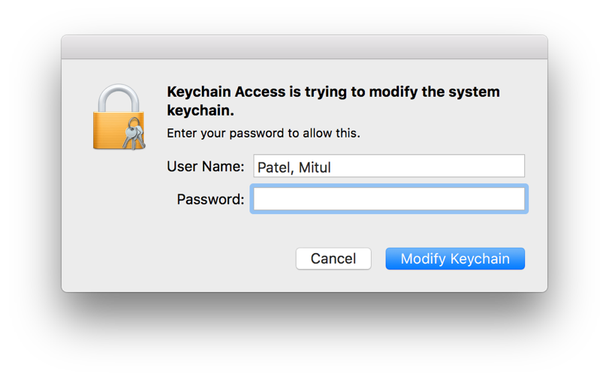

Close all windows and reboot Machine.